**Pick and Place Robot-Arm**



**PROJECT REPORT**

**BY**

**Yash Verma (2105849)**

**Sahil Rajput (2002868)**

**Priyanshu Singh ()**

**Shivam Pathak ()**

**Bachelor of Vocation**

**In**

**AI and Robotics**

**FACULTY OF ENINEERING**

**DAYALBAGH EDUCATIONAL INSTITUE**

**AGRA**

**Certificate**

This is to certify that project report entitled “**Pick and Place Robot-Arm”** being submitted by **Yash Verma (2105849), Sahil Rajput (2002868), Priyanshu Singh () and Shivam Pathak ()** undergraduate students in the Department of **Bachelor of Vocation** in **AI and Robotics**, **Dayalbagh Educational Institute Dayalbagh Agra**, India.

For the award of Bachelor of Vocational in AI and Robotics is an original research work carried by them under my supervision and guidance.

The project has fulfilled all the requirements as per the regulations of the Dayalbagh Educational Institute Dayalbagh Agra, India and in my opinion, has reached the standards needed for submission. The work, techniques and the results presented have not been submitted to any other university or institute for the award of any other degree or diploma.

...................................

Teacher sign

**Abstract**

**INTRODUCTION**

**Robotics** is a multidisciplinary field of study that encompasses various branches of engineering, computer science, and related disciplines. Robotics involves the design, construction, operation, and use of robots, which are machines that can be programmed to perform a wide range of tasks automatically or semi-autonomously.

Robots are typically equipped with sensors, actuators, and control systems that enable them to perceive their environment, make decisions, and perform physical tasks. They can be designed to perform a wide variety of functions, from simple repetitive actions to more complex operations that require advanced sensing, decision-making, and manipulation capabilities.

The field of robotics has a wide range of applications, including manufacturing, healthcare, defense, exploration, entertainment, and education. Robotics is also becoming increasingly important in the development of autonomous systems, such as self-driving cars and drones.

**Pick & Place Robotic-Arm** is a type of industrial robot that is specifically designed for automated handling of objects. It consists of a robotic arm, with a gripper or end-effector at the end, which is used to grasp and move objects from one location to another.

It’s commonly used in manufacturing, assembly, and packaging processes, as well as in material handling and warehousing applications. They are capable of performing a wide range of tasks, including picking up objects from one location, moving them to another location, placing them in a specific position, and releasing them.

Pick and place robotic arms can be programmed to perform a variety of functions, including repetitive tasks that are difficult or impossible for humans to perform efficiently. They are designed to operate continuously for long periods of time with high accuracy and precision, and can be customized to suit the specific needs of different industries and applications.

**HISTORY OF ROBOTS**

* 1920s: The first robots were created, mainly for use in industrial settings. The term "robot" was coined by Czech writer **Karel Capek** in his play "**Rossum's Universal Robots**".
* 1940s-1950s: The first electronic robots were developed. They were mainly used for military and space exploration purposes.
* 1960s-1970s: Robots started to be used in manufacturing and assembly lines. The first industrial robots were created by companies such as **Unimation** and **Kawasaki**.
* 1980s: Robots started to be used in other industries, such as healthcare and entertainment. The first robot-assisted surgery was performed in 1985.
* 1990s: Robotics technology continued to advance rapidly, with the development of more advanced sensors, actuators, and control systems.
* 2000s: Robots became increasingly sophisticated, with the development of artificial intelligence and machine learning technologies. This led to the creation of robots capable of performing more complex tasks and interacting with humans in more natural ways.
* Today: Robotics technology continues to advance, with the development of new materials, sensors, and other components. Robots are becoming increasingly common in a wide range of industries and applications, from manufacturing and healthcare to education and entertainment.

## 

## 

## LAW OF ROBOTICS

The "**Three Laws of Robotics**" is a set of rules proposed by science fiction author **Isaac Asimov** in his book "**I, Robot**". The laws are often cited as a framework for guiding the behavior of robots and artificial intelligence systems, and have been the subject of much debate and discussion in the field of robotics. The three laws are:

## A robot should not injure a human being or, through inaction, allow a human to be harmed.

## A robot must obey orders given by humans except when that conflicts with the First Law.

## A robot must protect its own existence unless that conflicts with the First or Second law.

## 

## 

## Design and Development

## Robotic Arm: The robotic arm was designed using aluminum extrusions and linear actuators. It has three degrees of freedom, which allows it to move in three directions.

## End-effector: The end-effector or gripper was designed using 3D printing technology. It is capable of gripping a wide range of objects.

## Control System: The control system was designed using an Arduino Uno microcontroller and a motor driver. The Arduino Uno was programmed using the Arduino IDE to control the motor driver and the robotic arm.

## Android App: The Android app was developed using Java and Android Studio. It allows the user to control the pick and place robot using Bluetooth communication.

## Screenshot 2023-05-11 173249.jpg

**Components**

A typical pick and place robot arm consists of the following components:

1. **Base**: The base is the foundation of the robot arm, and it supports all the other components.
2. **Joints:** The robot arm consists of several joints that allow it to move in different directions.
3. **End-effector:** The end-effector is the part of the robot arm that comes into contact with the object being picked up or placed.
4. **Sensors:** Sensors are used to detect the position and orientation of the object and the robot arm.
5. **Control system:** The control system is responsible for controlling the movement of the robot arm.
6. **Servo Motor:** Servo motors are used for moving the robot arm in particular directions. It’s help for pick and place an object.
7. **Arduino UNO:** Arduino Uno is used to control the robot arm. It’s a microcontroller that control the circuit of robot arm and the program of the robot arm is including in the Arduino.
8. **Bluetooth Module:** To establish a connection between the android application device and the circuit. It basically incorporates a serial communication between the android application device and the circuit.

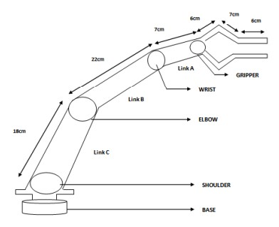

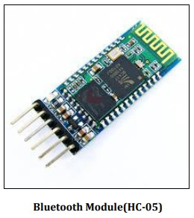 **Servo Motor(Mg-995)**

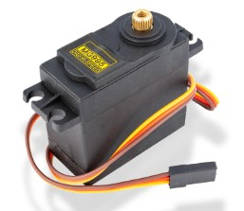

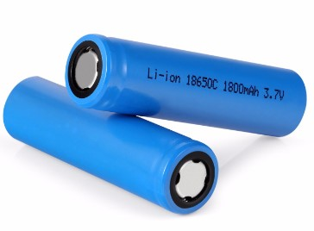

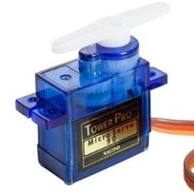

**Servo Motor (SG-90) 5V External Power Source**

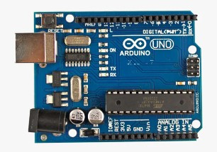

**Microcontroller [Arduino-UNO]**

**Circuit Diagram**

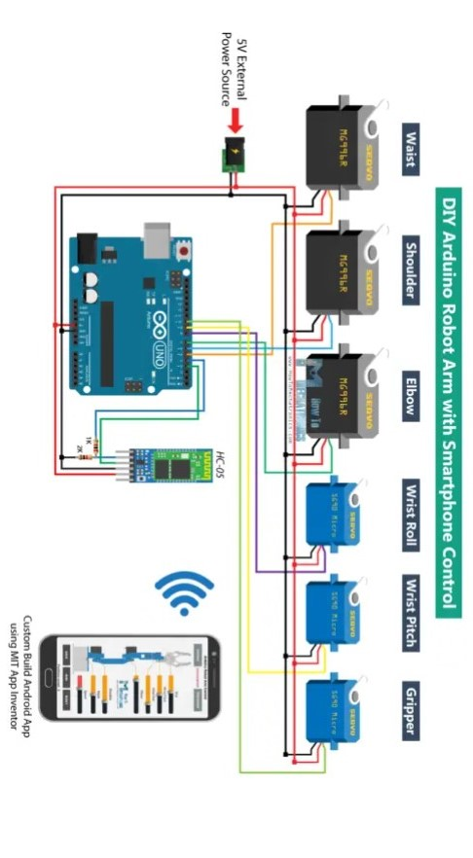

## Working Principle

The working principle of a pick and place robot arm is based on the movement of its joints. The robot arm consists of several joints that can move in different directions, such as up-down, left-right, and forward-backward. These joints are controlled by a computer program that determines the movement of the arm.

The pick and place robot works as follows:

1. The user launches the Android app and connects to the pick and place robot using Bluetooth communication.
2. The user selects the pick or place option from the app and enters the location of the object to be picked or placed.
3. The Arduino Uno receives the command from the Android app and controls the motor driver to move the robotic arm to the specified location.
4. The end-effector or gripper is then used to pick up or place the object at the specified location.

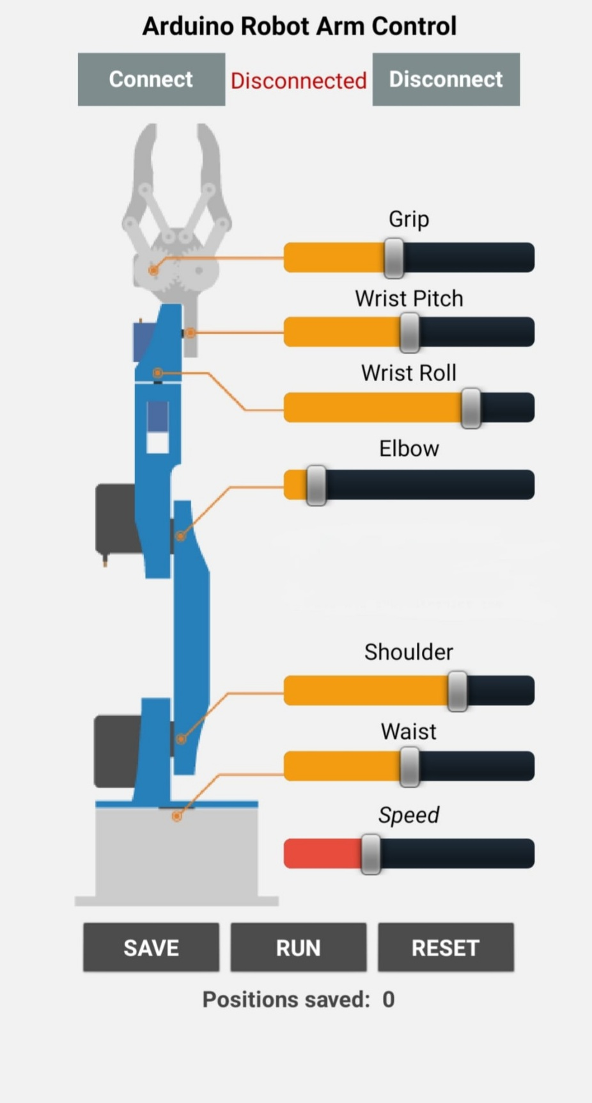

**Types of Pick and Place**

There are several types of pick and place robot arms available in the market, such as:

1. **Cartesian robot**: This type of robot arm has three linear joints that move along the X, Y, and Z axes.
2. **SCARA robot:** SCARA stands for Selective Compliance Assembly Robot Arm. This type of robot arm has two parallel joints that move in the X and Y axes and a third joint that moves in the Z axis.
3. **Articulated robot:** This type of robot arm has multiple joints that allow it to move in a variety of directions.

**Applications**

Pick and place robot arms have a wide range of applications in manufacturing industries, such as:

1. **Assembly line work:** Pick and place robot arms can be used to assemble products on the assembly line.
2. **Material handling:** Robot arms can be used to move materials from one location to another in a factory.
3. **Packaging**: Robot arms can be used to package products in a factory.
4. **Manufacturing:** Pick and place robots are widely used in manufacturing industries for assembling, sorting, and packaging products. They can pick up raw materials or finished products and place them in the right location with high accuracy and speed.

**Advantages**

Pick and place robot arms offer several advantages over manual labor, such as:

1. **Increased productivity:** Robot arms can work continuously without getting tired or taking breaks, which increases productivity.
2. **Improved quality:** Robot arms can perform tasks with precision and accuracy, which improves the quality of the work.
3. **Reduced labor costs:** Robot arms can replace manual labor, which reduces labor costs.
4. **Improved accuracy:** Pick and place robots can be programmed to pick up and place objects with high accuracy, reducing errors and waste.
5. **Flexibility:** Robot arms can be programmed to perform a wide range of tasks, making them suitable for various applications across different industries.

**Conclusion**

In conclusion, the app-controlled pick and place robot arm is a versatile industrial robot that can be used in various applications. With the help of a mobile app, it becomes easier to operate and allows for greater flexibility in the manufacturing or assembly process. With further development and advancements in technology, the pick and place robot arm will continue to play a vital role in the manufacturing industry.

Pick and place robot arms are widely used in manufacturing industries for tasks such as assembly line work, packaging, and material handling. They offer several advantages over manual labor, such as increased productivity, improved quality, and reduced labor costs. There are several types of pick and place robot arms available in the market, such as Cartesian, SCARA, and articulated robots, each with its own unique features.